**AI ML**

1995 john mc Carthy created the first ai workshop.

In 1956 we crete a mechine with general intelligence.Allen Navell and Horbert created the program.

One of the mojor thing is the physical symbol system Hypothesis.

The symbolic system approach is a weak AI , In 1980 we just call those as a Expert system.

Symbolic Reasoning : Long set up but no out side data.  
  
mechine Learning : large volumes of data may need tweaked or updated.

Regression analysis : used to established the relation between the variables and estimate the values.maximum likely hood estimation.

Note : Artifical neural networks will only show you the patterns , it doesn’t provide the answers.

Supervised learning: ai put all the list songs in a jazz folder

Un supervised learning: the ai just feed all the songs in a folder based on your play songs, regions  
Un supervised learning will generate AI-created categories.

When ever you multiply a number with a list it will give the result 2 times

A=[1,2]

A*2=[1,2,1,2]

B=np.array(A)

B*2=[1,4]

The dot product of two vectors is a.b=b.a

a(b+c)=a.c+a.b

np.dot(a,b) is same as np.dot(b,a)

let us take a=[1,2,3,4,5]

b=[6,7,8,9,10]

c=[11,12,13,14,15]

np.dot(a,b)=130

multiplay each corresponding index and add all of them.

a(b+c)=a.c+a.b --------🡪335

for this add b,c list index values and then multiply the a list with the resulting.

Magnitude of the vector : also called norm of the geometric length is the distance from tail to head vector. Represented ||a||

Sqrt of summission i=0 to n xi pow(2)

There is a function norm in numpy  
we just write np.norm(a)

The project on b from a is =a.b/||b square||.b

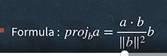

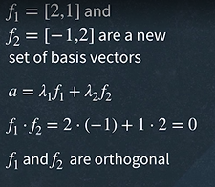

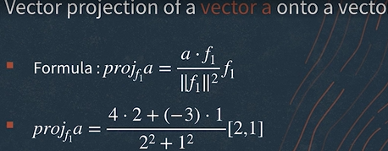

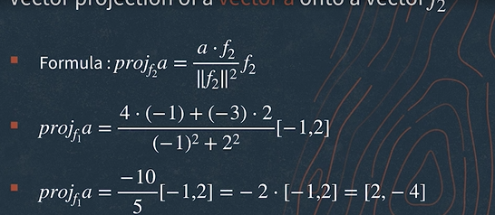

The inverse of matrix can be Ainverse=1/det(A)[1 3 4

3 6 9]

Eigenvalues and vectors

Keras and tenserflow

Liner Regression :  
y=ax+b

X is independent variable and y is dependent variable

A is the slope and b is the intercept

Y=ax1+ax2+……………..+anxn+b

Logestic Regression : it is a binary model give relation between two or more variables. And outputs 0 or 1

Y=f(ax1+ax2+……………..+anxn+b)

Trail and error method : 10=2a+b

We estimate the values by using trail and error method.

Perception :

it is an algorithm for supervised learning for binary classification.

It is a single cell in a neural network.

It is based on logestic regression.

Also called a node in the neural network.

Nodes organized as layers.

Each node have bias, weight and activation functions

We supposed to take weight w, bias b and function f

Y=f(a1w1+a2w2+……………+anwn+b)

Each node in the layer is not connected to nodes within layer but connected to next layer and form a dense network.

Each neural network have one input layer and multiple hidden layers and one out put layers.

In input layer there is one node in each independent variable , in the below example there are there

The hidden layers node are different these will be vary from case to case.

The no.of layers in the out put layer will vary by types of predections.

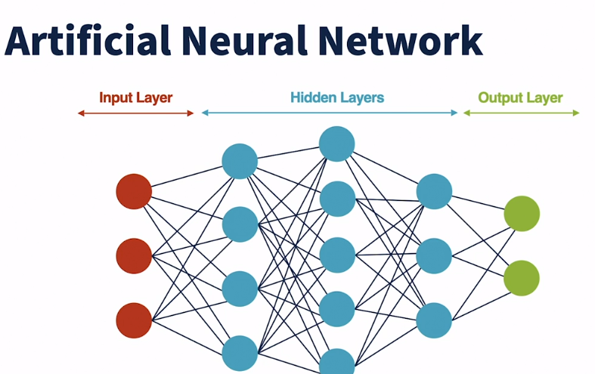

Training Model : is the best to determine the value for the perameters and hyper parameters that maximize the accuracy.

The parameters like weight , bias,layer, node e.tc

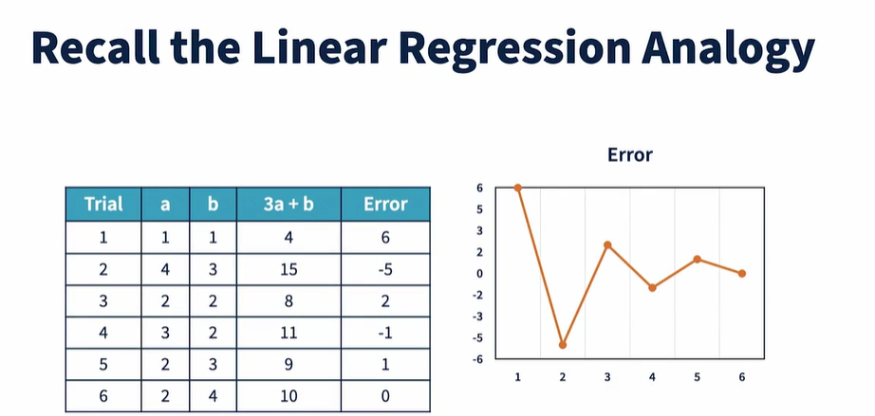

Vector : Is a orderlist of numeric values. It is a tuple of one or more values.

Vectors are usually defined by using num py array.

It represent feature variable for the prediction.

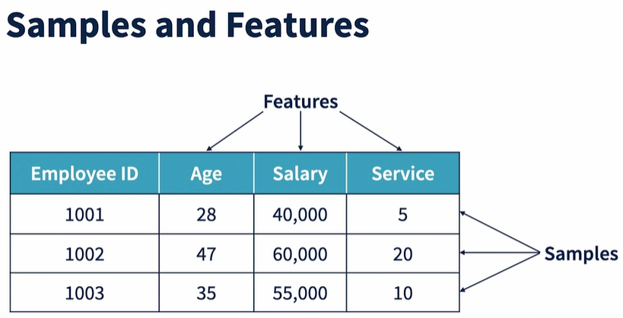

For text documentation each document is a sample its numeric values is a features.

For image image is a sample and its pixel is a feature.

INPUT PROCESSING :

Activation layer : determine the nodes to propagate information to the next layer.

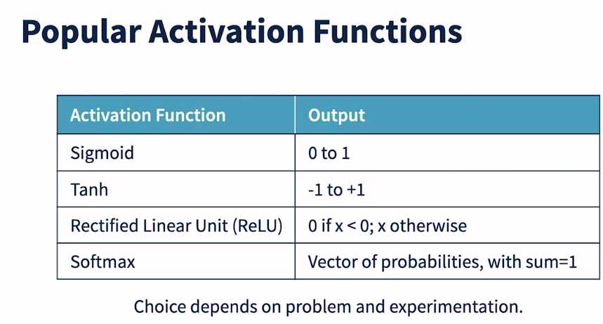

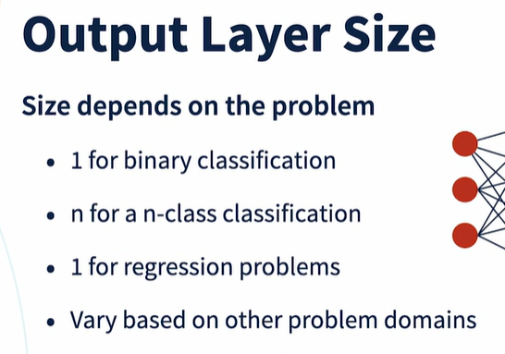

Splitting Input :

Training Set: fit the parameters

Validation set: used for model selection

Test set : used for model performance.

Useul split: 80:10:10

The weights initialization shold not be a zero initialization it should be some random standard normal distribution(mean=0 ,sD=1)

Measuring accuracy and error are the alternative terms that can be used to fill the gap b/w predicted value and original value.

LOSS AND COST FUNCTIONS :

LOSS: Measure the prediction for a single sample   
Cost : Measure the prediction for the set of samples

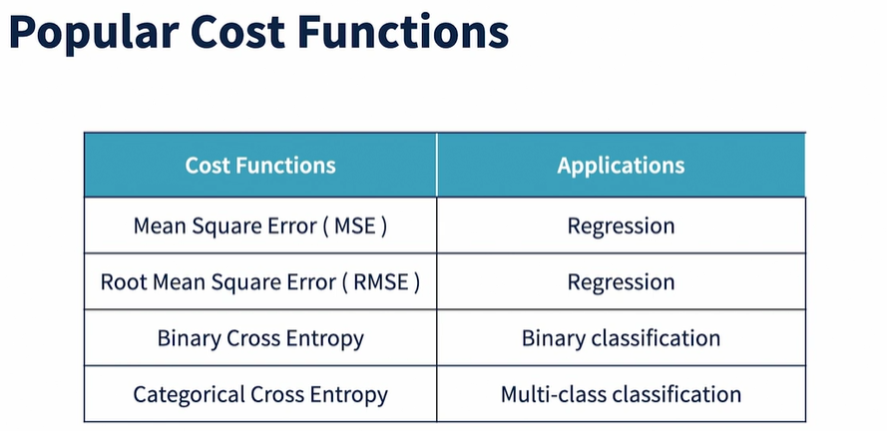

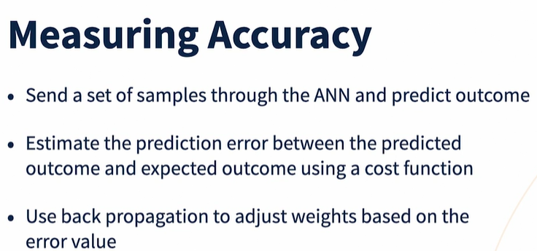

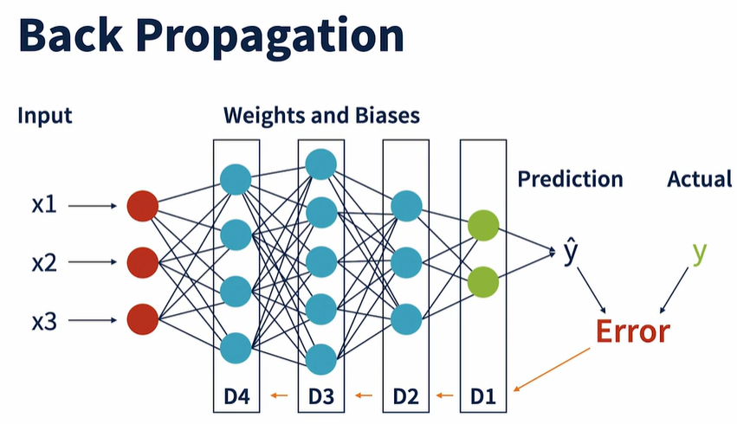

We compute the eerors using a cost function.then we use back propagation to run ,edit and adjust the weights and biases this one pass learning we have to do this again and agaian as the weights and biases are refined.

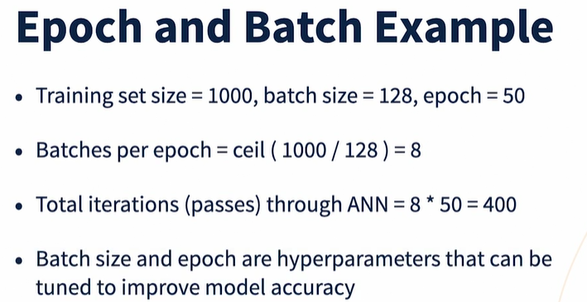

**An ANN model**

[- [Instructor] Having now seen the neural network constituents and the training process, let's recap the question. What is an ANN model? What does it contain? An ANN model is represented by a set of parameters, namely the weights and biases that are obtained during training. When someone says that the model has X parameters, they are mentioning the total count of weights and bias values in the model. A model is also represented by a set of hyperparameters. This includes the number of layers, nodes in each layer, activation functions in each node, cost functions, optimizers and the learning rate used. It also includes the batch size and epoch values used to train the model. A model file typically contains the representation of all these values. Models can be saved to files, shared and loaded into other binaries if needed. Once you have a model, what does the prediction process look like? The prediction process is exactly the same as the forward propagation step, except that the input data used is the feature attributes for prediction and the target value is not known, so the steps involve pre-processing and preparing the inputs, passing them through the layers, computing the outputs in each node using their final weights and biases and deriving the outcomes in the final layer. The predictions may also need to be post-processed for converting them to business representations.](https://www.linkedin.com/learning/deep-learning-getting-started/an-ann-model?autoSkip=true&contextUrn=urn%3Ali%3AlyndaLearningPath%3A1~AAAAABAhslo%3D2834115&resume=false&u=270643802)

Popular Neural Networks :

LeNet5 – built for document and hand writing recognition.

ALEXNet: for Image Recognition.  
RESNet : Over come the limitations of ALEXNet

Lstm : For predicting sequence of text.  
Transformers : For Revolutionary of Genarative AI

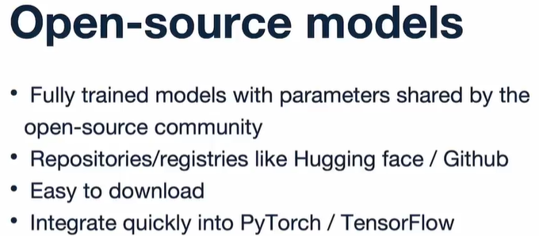

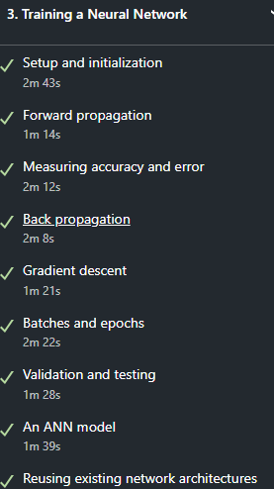

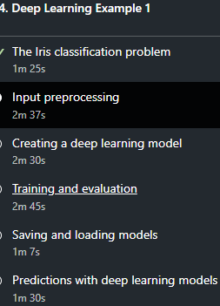

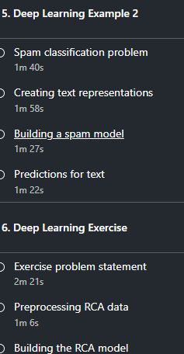

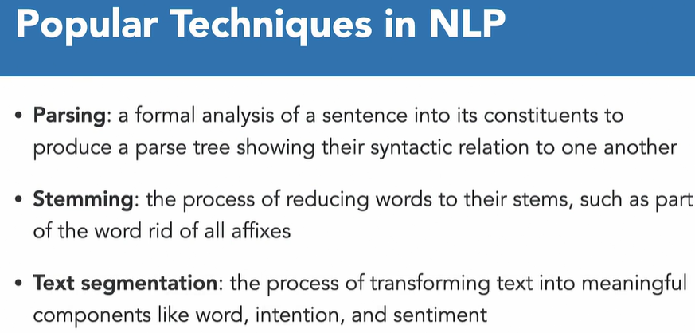

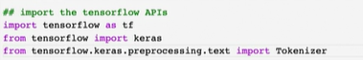

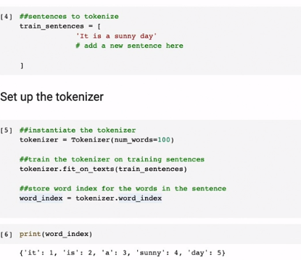

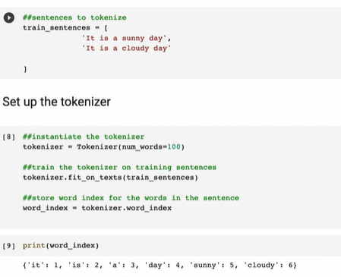

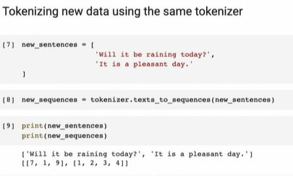

If we use oov it wiil added to the list at zero index.

from keras.preprocessing.text import Tokenizer

from keras.preprocessing.sequence import pad_sequences

# Word encoding dictionary

word_index = {'i': 1, 'am': 2, 'craving': 3, 'for': 4, 'ice': 5, 'cream': 6}

# Sample sentences

sentences = ["I am craving for ice cream!", "I am feeling hungry"]

# Create a tokenizer

tokenizer = Tokenizer()

# Set the word index for the tokenizer

tokenizer.word_index = word_index

# Convert sentences to sequences of integers

sequences = tokenizer.texts_to_sequences(sentences)

# Print sequences

print(sequences)

# If you want to pad sequences to have the same length

max_length = max(len(seq) for seq in sequences)

padded_sequences = pad_sequences(sequences, maxlen=max_length, padding='post')

print(padded_sequences)

Word Embededing for sentimental analysis.

The embedding layer can capture relationships between words in dense vectors.

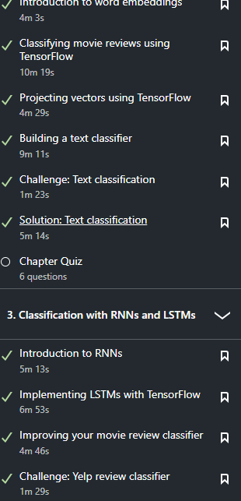

GENARATE POETRY:  
  
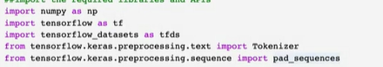

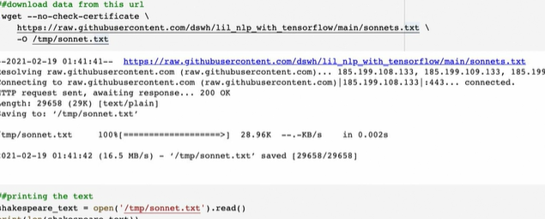

REMOVING COLOR

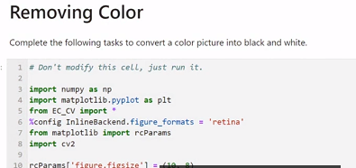

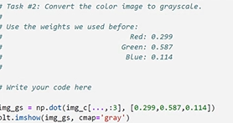 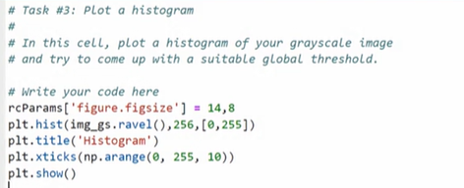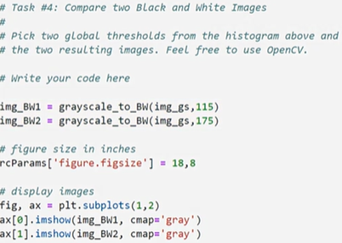

Difference between median average and gaussian filters.Edgedetection, sobel filters

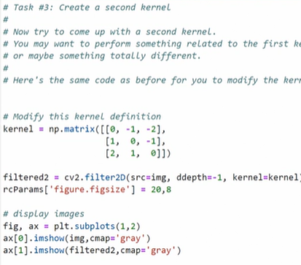

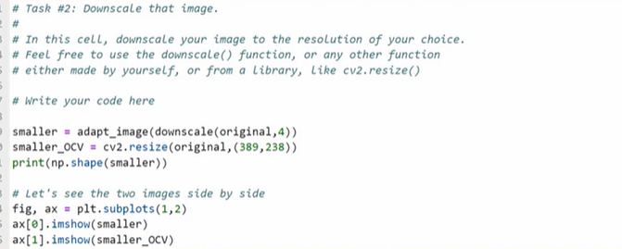

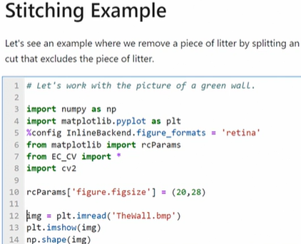

Panoramic is the thing which help to make the 3 images into a single images like stiching but it includes the blending of image.

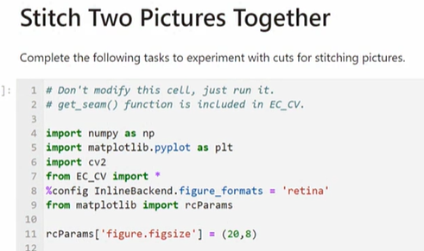

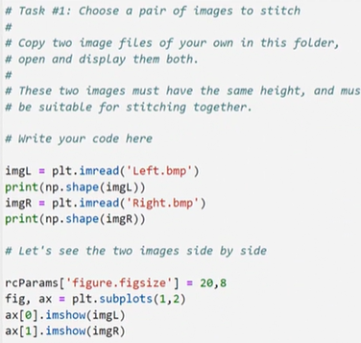

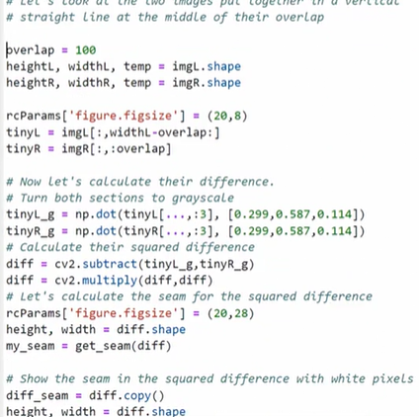

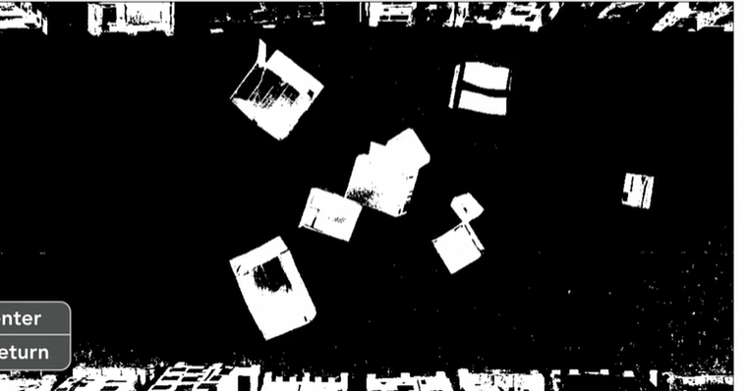

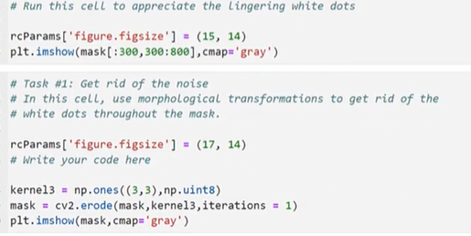

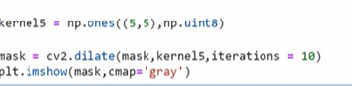

Markov Decision Process.

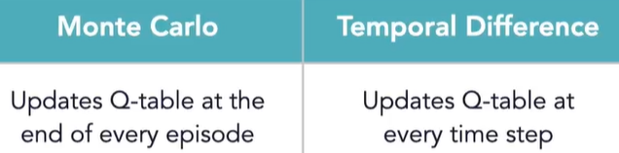

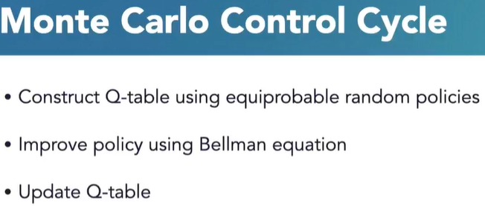

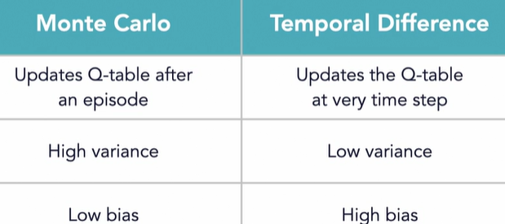



[that. So here's my own answer. Reinforcement learning is a form of machine learning, or basically one of the ways machines learn that involves interaction with the environment and learning from their own actions, as opposed to learning from history or previously recorded datasets. If you're a product manager, a machine learning developer, or a researcher, you already know what you want to do with your knowledge from this course. However, if you're new to the field of artificial intelligence, I have some suggestions for you. First, learn about the other machine learning techniques for supervised and unsupervised learning, learn more about neural networks and deep neural networks, understand what deep learning is before you dive into deep reinforcement learning. There happens to be some great resources on LinkedIn Learning, so you don't have to go far. I also have some projects I've personally worked on with reinforcement learning at khaulat.github.io. If you have any questions during your learning journey, you can always ask in the question and answer section. Myself or someone else will be able to help you out.](https://www.linkedin.com/learning/reinforcement-learning-foundations/your-reinforcement-learning-journey?autoSkip=true&contextUrn=urn%3Ali%3AlyndaLearningPath%3A1~AAAAABAhslo%3D2834115&resume=false&u=270643802)

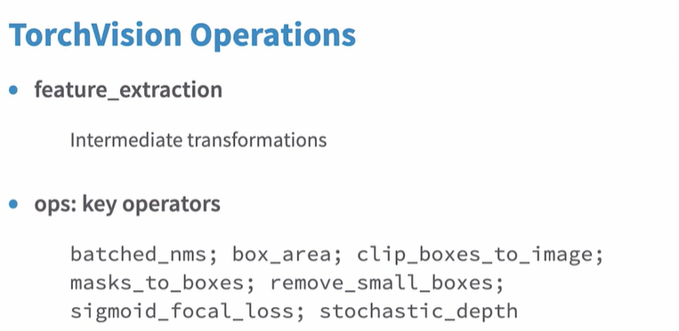

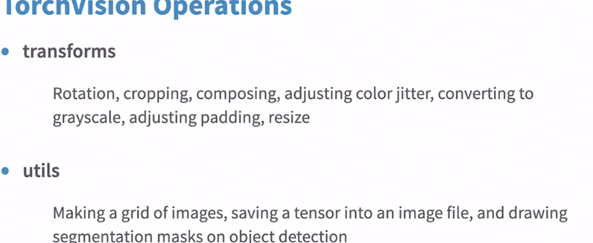

Torch text and torch Audio.

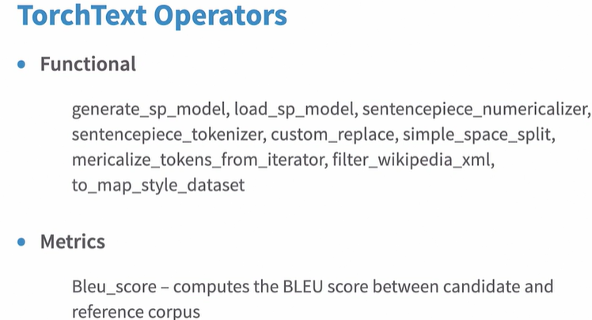

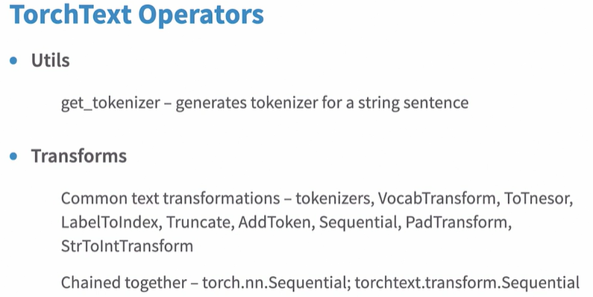

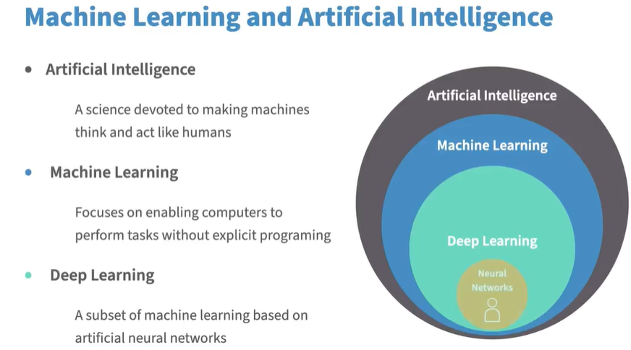

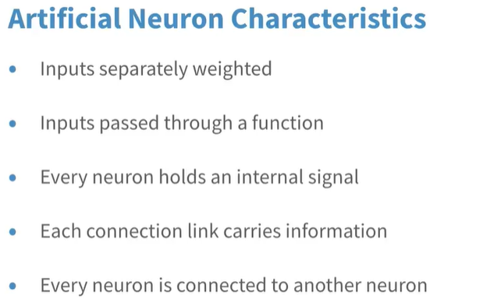

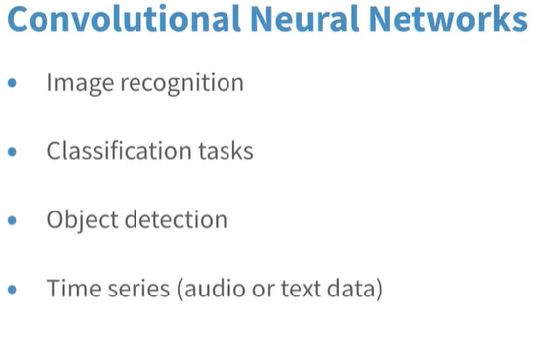

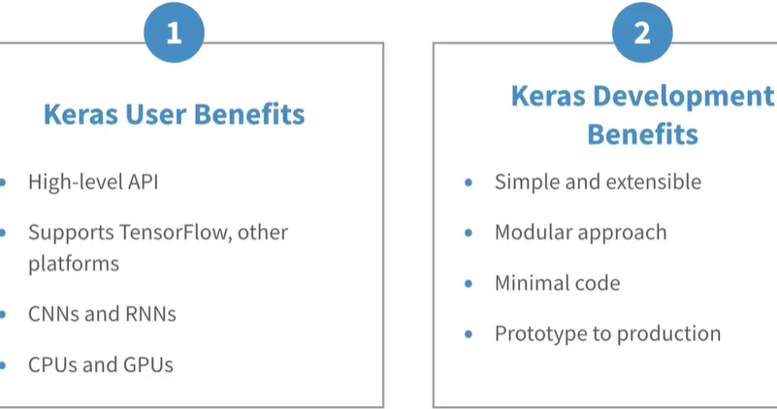

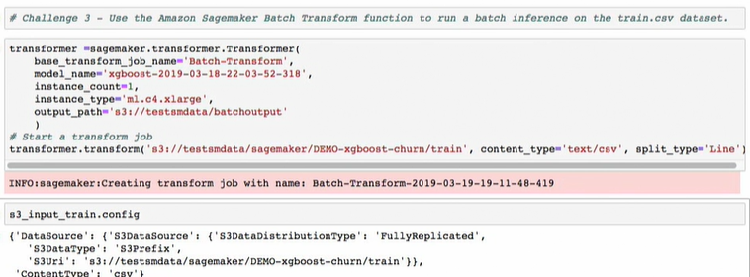

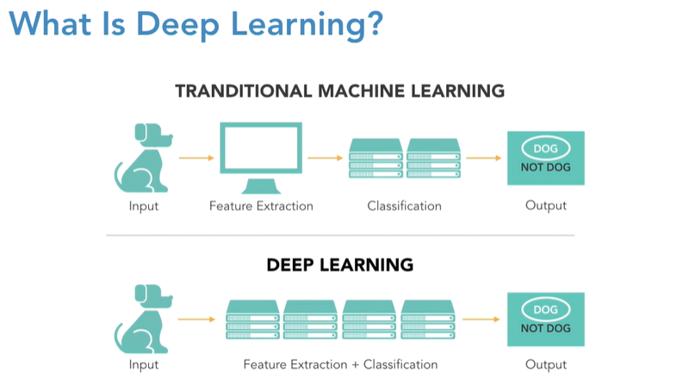

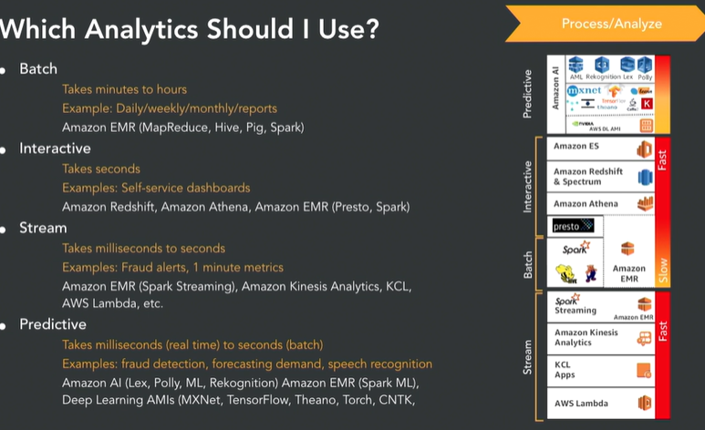

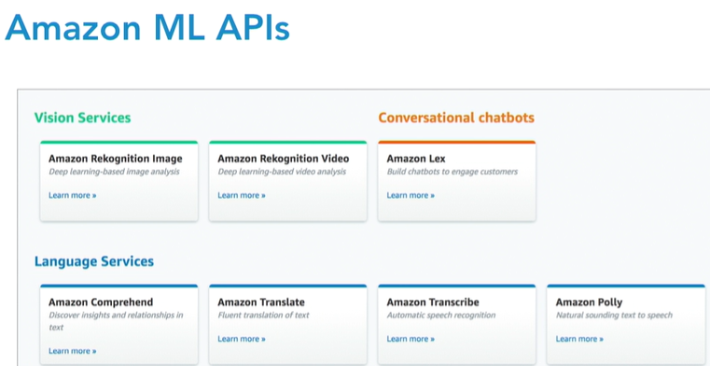

Go to the aws portal and search comprehend , there you will see some of the terms or words in the middle box , in the right side it give the entity . if you type anything in the box , and click analyse it will give you the entities based on your input.

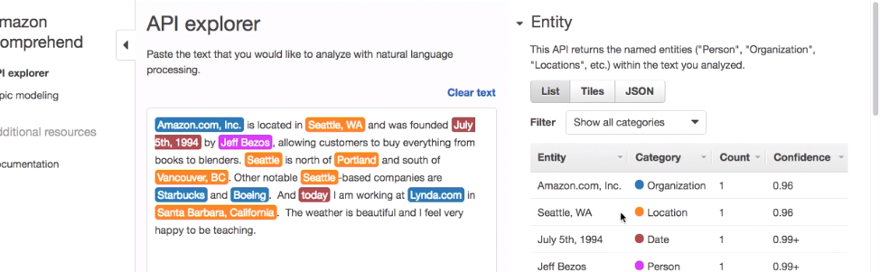

If you scrolldown it will give the sentimental analysis also.

By click on the topic modelling , you can create a model;

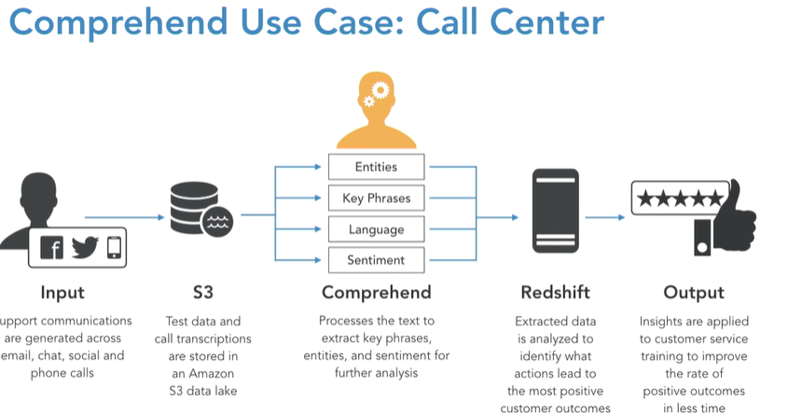

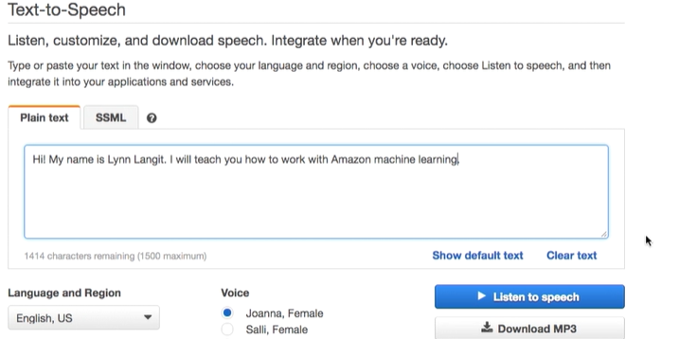

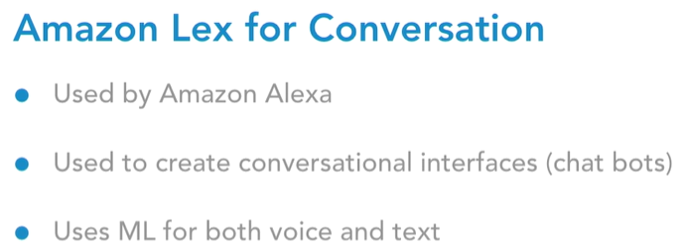

Go to aws and click aws Lex

Create a chat bot.

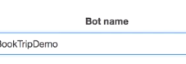

Upload a data set into in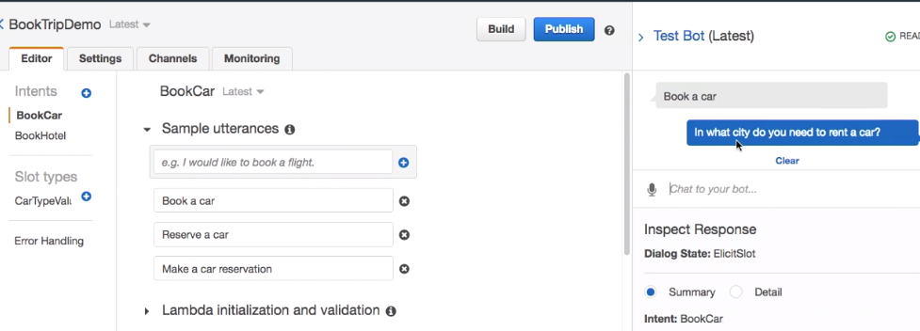

In aws services , search recognization , try demo ,then upload an image , or text with img, celebreity , facial , vedio too e.tc

In aws , go to amazon machine learning and then upload a data set into it

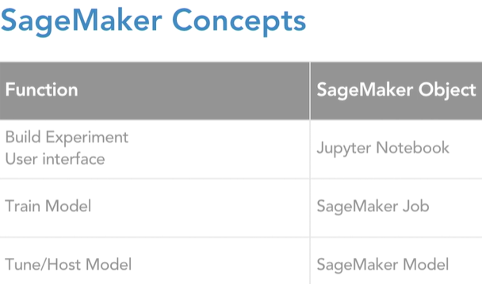

In the aws console go to sage maker , create a note book instance.

And then write something in that using a selected language(python or any)

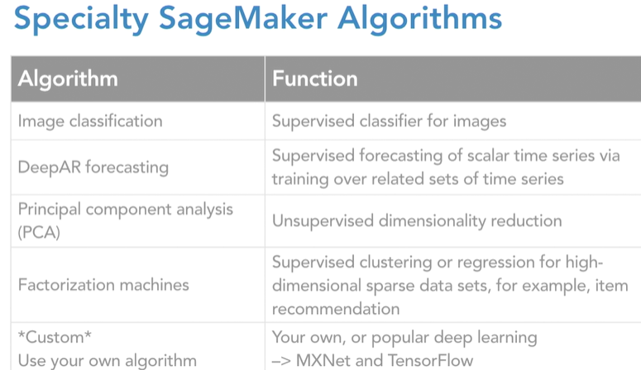

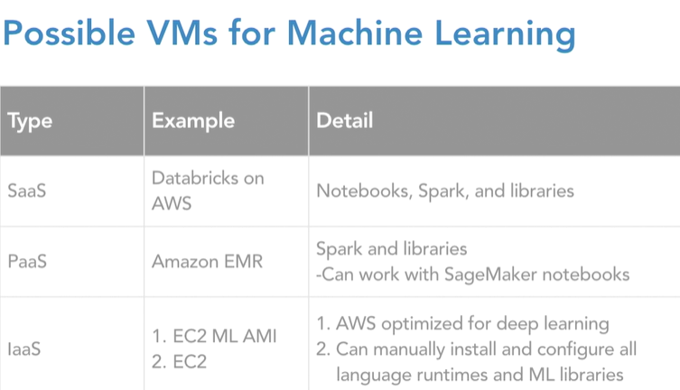

WORKING WITH MXNET AND DATABRICKS

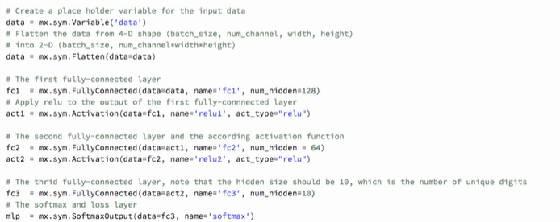

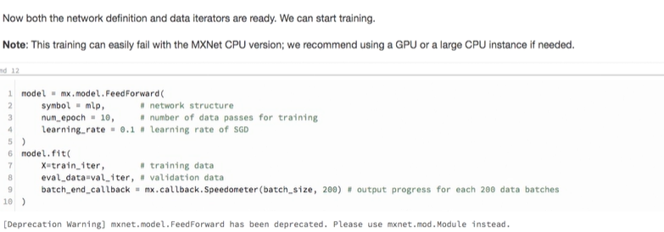

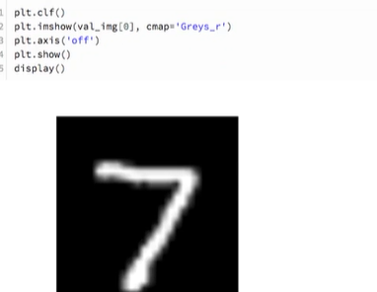

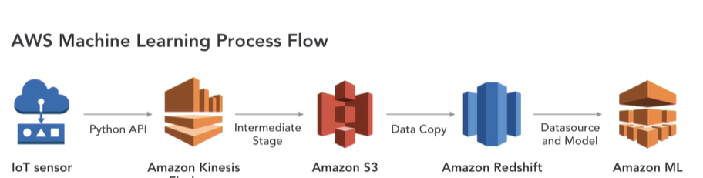

POWER BI

In power bi we can make the clustering by click on the ellipse button and click auto clustering. And give the no.of clusters , if you want to edit the cluster then go to legend and edit the cluster option.

The forecasting is only for the line chart only.

Why do we use the anomaly In power bi